8. React-JS HOL

Name:- Shubham Sangram Bej

Hands-on 8

Objective
- Understand the concept of React State.
- Use the constructor to initialize state variables.
- Update state values dynamically using setState().
- Handle button click events in React.

Software Requirements
- Node.js
- npm
- React
- Visual Studio Code

Project Name
counterapp

Procedure
- Created a new React application named counterapp.
- Created a class component named CountPeople.
- Initialized two state variables:
  - entrycount
  - exitcount
- Used the constructor to initialize both counters to zero.
- Implemented the updateEntry() method to increment the number of people entering the mall.
- Implemented the updateExit() method to increment the number of people leaving the mall.
- Used setState() to update the state whenever the respective button was clicked.
- Designed the interface using CSS with green buttons and black button text.
- Executed the application using:
npm start
- Verified the browser output by clicking the Login and Exit buttons.

Output
The application successfully increments the number of people entering and exiting the mall whenever the respective button is clicked.
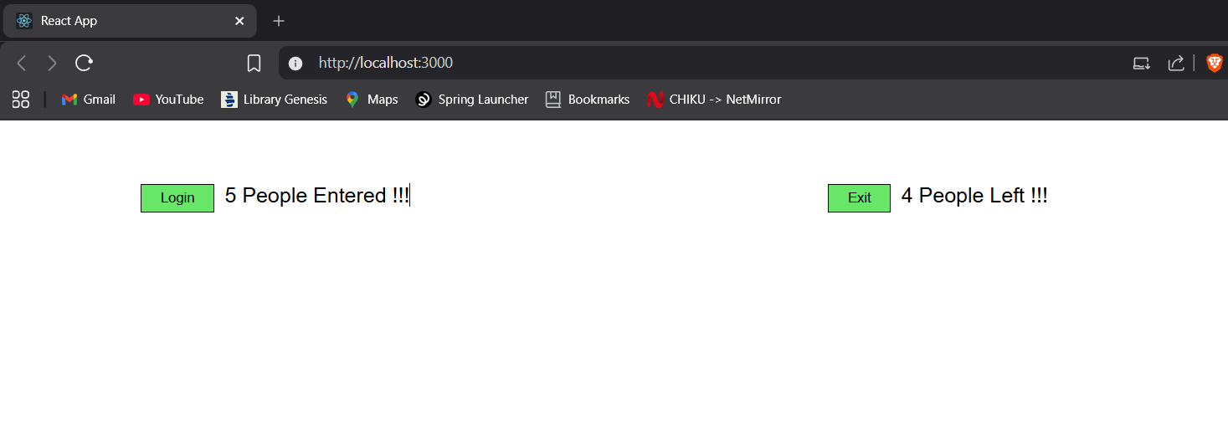

Result
The React application counterapp was successfully developed using React State and event handling. State values were updated dynamically using setState().

